1. 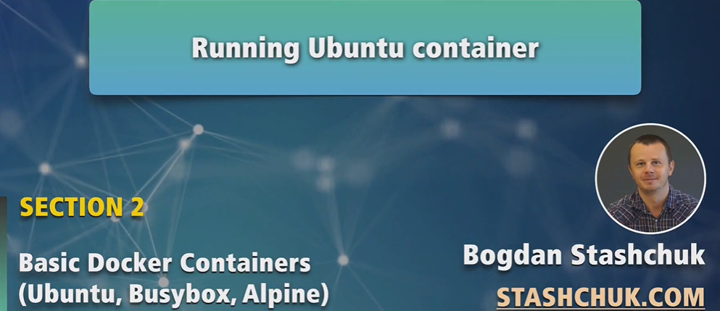
2. 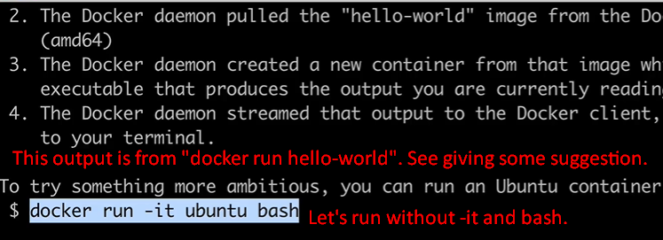
3. “docker run -it ubuntu bash” with this command, we will be able to create another container using ubuntu image.
4. Let’s try the command “docker run ubuntu” without -it and bash as we did with “docker hello-world”.
5. 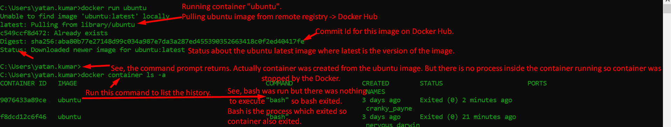
6. Now we know that when ubuntu container is created, bash process is run. Now we want to run some commands on that bash process inside the container. How?
7. Run the command “docker run -it ubuntu”
8. 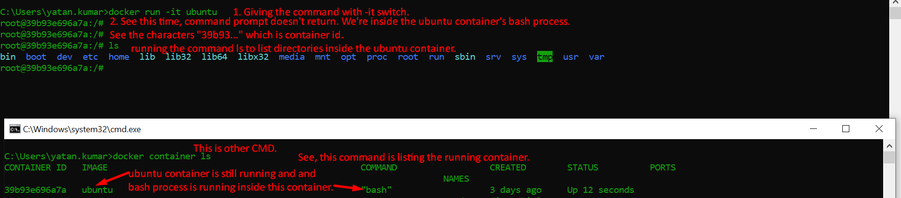
9. **NOTE**: This Ubuntu container runs full-featured Ubuntu OS.
10. 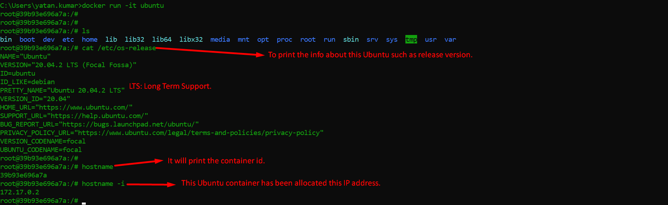
11. 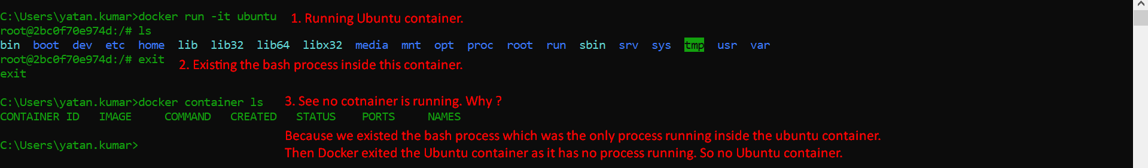
12. 